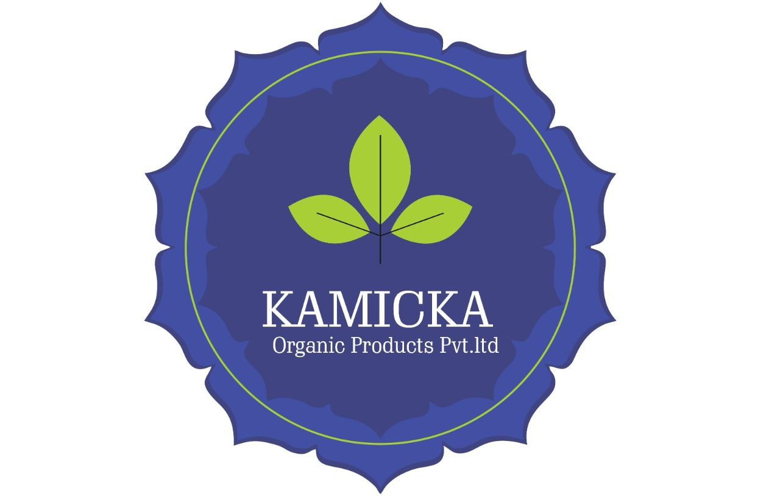

Kamicka Natural Hair Shampoo - Data Sheet
Shelf Life: 12 Months (with Natural Preservatives)
Preservation System: Natural antioxidants & herbal cleansers ensuring purity and scalp-safe freshness.

Label Claims
- Paraben Free - Vegan (Some Products) - SLS Free - Cruelty Free - No Artificial Colors – No Synthetic Fragrances
-No Chemical Preservatives -No Palm Oil

Benefits of Using Natural Hair Shampoo
Kamicka Natural Hair Shampoos are formulated with botanical extracts, fruit enzymes, and Ayurvedic herbs to gently cleanse, nourish, and protect the scalp and hair. These shampoos are designed to address specific hair concerns while maintaining natural balance.

Key Benefits:
- Gently cleanses without stripping natural oils
- Reduces hair fall and scalp irritation
- Controls dandruff and flakiness
- Enhances shine and smoothness
- Suitable for daily use and sensitive scalps

Natural vs Chemical Hair Shampoo
Parameter | Natural Hair Shampoo | Chemical Hair Shampoo
Ingredients | Herbal extracts, mild surfactants | Sulphates, synthetic foaming agents
Scalp Compatibility | Gentle, suitable for sensitive scalp | May cause dryness or irritation
Long-Term Use | Supports scalp health naturally | Can weaken hair roots over time
Fragrance | Natural essential oils | Artificial perfumes
Environmental Impact | Biodegradable, eco-safe | May contain non-biodegradable residues

Product Range & Benefits
Shampoo Variant | Target Concern | Primary Benefits
Mixed Herbs Premium Shampoo | Dull, lifeless hair | Revives hair, adds volume and shine
Hairfall Control Shampoo with Coconut Milk | Hair fall | Strengthens roots, reduces breakage
Lemon Anti-Dandruff Shampoo | Dandruff | Controls flakes, purifies scalp
Rose Shampoo | Dry & frizzy hair | Hydrates, smooths, adds softness
Rosemary Shampoo | Hair growth | Stimulates follicles, improves circulation
Shea Butter, Amla & Shikakai Shampoo | Split ends & frizz | Repairs damage, improves texture

Usage Instructions
- Apply shampoo to wet hair and scalp.
- Massage gently to lather and rinse thoroughly.
- Use 2–3 times a week or as needed.
- Patch test recommended before first use.

Storage
- Store in a cool, dry place away from sunlight.
- Keep bottle tightly sealed after use.
Customization Option available.
Gentle by Nature, Pure by Care.
Manufactured by Kamicka Organic Products Pvt. Ltd.
Made in India | www.kamicka.com | +91-7801828095 | business@kamicka.com

